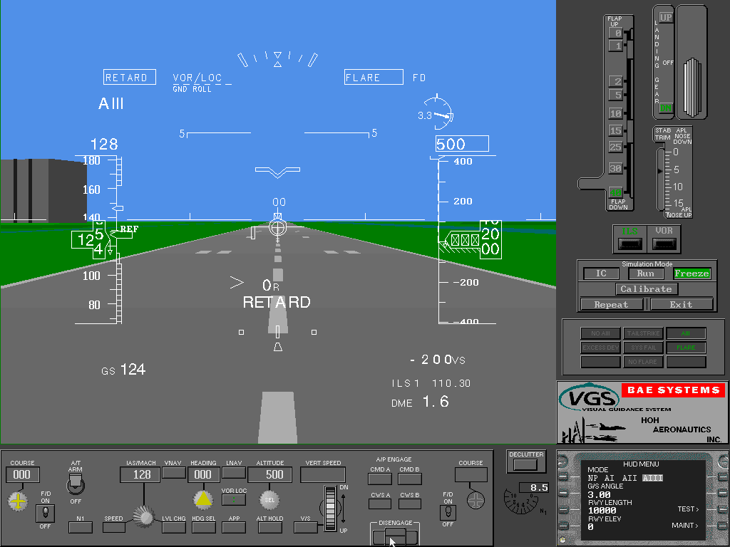Head-Up Display Development and Testing

Hoh Aeronautics, Inc. (HAI) has been in the business of developing symbology and control laws for Head-Up displays (HUD) for civil transports since 1989. Our most recent and comprehensive effort was the development, flight-testing, and FAA certification of a new HUD for the Boeing 737-800, termed the Visual Guidance System or VGS. This work was accomplished under contract to BAE SYSTEMS in Rochester England and Seattle, Washington. BAE SYSTEMS (formerly Marconi Avionics) is the world leading producer of military HUDs (e.g., F-16, C-17). HAI’s role has been to assist BAE SYSTEMS to develop a HUD for the civil market.

HAI remains active in the civil HUD business, developing symbology and control laws for HUD installations for other aircraft, formulating upgrades to the 737-800 VGS, and developing VGS training software. HAI is now an integral part of the BAE SYSTEMS VGS team, and has a five-year retainer agreement in place to continue work on head-up displays.

HAI’s HUD development work for the pas three years has been to develop the symbology and control laws for the new civil HUD product, and to assist BAE SYSTEMS in marketing the system to American Airlines. The HUD symbology was developed in close coordination with American Airlines pilots under the concept that it was to be compatible with the head down primary flight display (Figure 1 at left). A declutter screen was also developed using basic concepts from the High Speed Civil Transport (HSCT) program (Figure 2). Pilots may select the Normal display (left) or Declutter display (see below) at any time via a switch on the side of the HUD combiner.

VGS Normal Mode in landing flare as shown on HAI PC Simulator. This real-time simulator is used as an engineering development tool as well as part of a training package for American Airlines pilots.

|  |
| --- |
|  |

The flight director control laws were developed using the physically intuitive pursuit guidance techniques developed at NASA Ames Research Center for use on the HSCT. Many other innovative concepts have been implemented into the BAE SYSTEMS HUD. These are summarized below.

**SUMMARY OF VISUAL GUIDANCE SYSTEM FEATURES**

* •        A full time flare cue is available for all landings. This ensures a repeatable flare regardless of weather conditions, runway slope, etc.
* •        Runway Remaining is displayed during the takeoff and landing ground-roll
* •        Advisory ground-roll guidance is available for the landing rollout
* •        The ground-roll symbology is highly intuitive in that the flight director and raw data are combined into a single set of symbols (i.e., pursuit guidance). The takeoff guidance allows a reduction in takeoff visibility to 300 RVR.
* •        The HUD control laws provide tailstrike protection for landing through integration of an alert annunciation, TAILSTRIKE, and the full time flare cue
* •        The HUD control laws provide tailstrike protection on takeoff through advisory pitch guidance.
* •        The VGS is the firstHUD to be certified under the stringent requirements of FAA Advisory Circular AC 120-28D. Among other things, this required the demonstration of Monte Carlo simulation results and flight test validation at high altitude airports.
* •        The VGS is certified for Cat IIIa landings with all approved landing-flap settings (including 15 deg flaps), with one engine out, and with autothrottles on or off.
* •        An unusual attitude mode automatically appears to provide instant attitude awareness in the event of an aircraft upset. (Figure 3)
* •        The acceleration caret symbol provides the correct thrust lever command guidance to hold airspeed in all types of wind and windshear.
* •        An ENGINE OUT annunciation is provided in the event of an engine failure
* •        Mach compensated angle-of-attack is displayed along with the approach band and stick-shaker limit.

|  |
| --- |
| Illustration of VGS unusual attitude mode. Note that the entire pitch scale is visible so that it is not necessary to read numbers to determine the attitude. Also note that the display is decluttered to show only information necessary to recover. |

* •        Comprehensive annunciations are provided to allow the crew to interpret the proper course of action in all flight situations (e.g. EXCESS DEV and NO FLARE).
* •        Armed and active modes are displayed for the lateral and longitudinal axes of control, as well as for the HUD mode (e.g. NP, AI, AII, and AIII). Switching to the selected approach mode from the Non-Precision (NP) mode is automatic at glideslope and localizer capture.





Insert cockpit photo

|  |
| --- |
|  |

|  |
| --- |
|  |

# VGS Declutter Symbology in Flare

|  |
| --- |
|  |

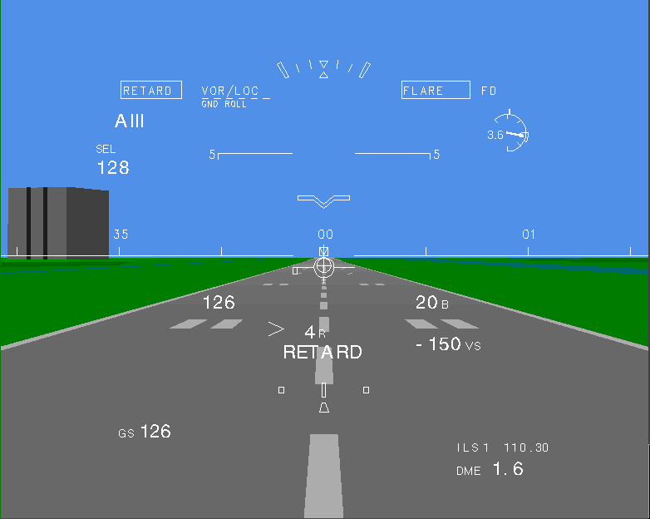

Roger Hoh of HAI was the Project Test Pilot and Flight Test Director for all engineering flight-testing on the HUD development project. Flight testing was conducted out of the BAE SYSTEMS facility at Mojave, CA.

Illustration of VGS ground-roll symbology. As long as the “landing gear legs” of ground path symbol are over the localizer symbol, the aircraft will return to centerline.

|  |
| --- |
|  |

|  |
| --- |
|  |

|  |
| --- |
| Photo – Short final h=370 ft view thru HUD if scans in okay |

View through VGS combiner on short final to Oakland during engineering flight testing

|  |
| --- |
|  |

Boeing 737-200 used for initial engineering flight test development.

|  |
| --- |
|  |