Development and Certification of Head-Up Display Guidance and Symbology for Civil Aircraft



BAE Systems Visual Guidance System Approach to OAK – 737-800 BAE VGS

Hoh Aeronautics, Inc. (HAI) has been in the business of developing symbology and control laws for Head-Up displays (HUD) for civil transports since 1989. This has included work with Flight Dynamics, Inc. (now a division of Rockwell Collins), to develop the guidance for Cat IIIa landings and low visibility (300RVR) takeoff for HUDs used by Southwest Airlines (Boeing 737) and Horizon Airlines (DeHavilland Dash 8).

Subsequent to the work for Flight Dynamics, HAI was employed by BAE systems to develop and accomplish FAA certification of the guidance and symbology for a civil HUD, known as the BAE Visual Guidance System or VGS. This work included initial flight testing on a Boeing 737-200 test bed and later on a Boeing 737-800, from the BAE flight test facility in Mojave, California. All engineering flight test was accomplished by Roger Hoh both as research pilot and FAA DER test pilot. A paper on HUD development and flight testing was presented to the Society of Experimental Test Pilots (SETP) and can be accessed by this link – [Development and Flight Test of a Commercial Head-Up Display](SETP_HUD_Paper.pdf).

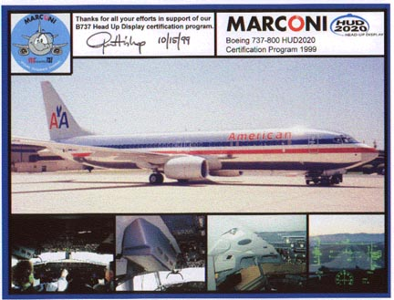

This Cat IIIa certified HUD is currently used by American Airlines and South African Airlines. HAI also developed a fully interactive PC simulation and computer-based training program to support the VGS. A screenshot of that simulator is shown below.

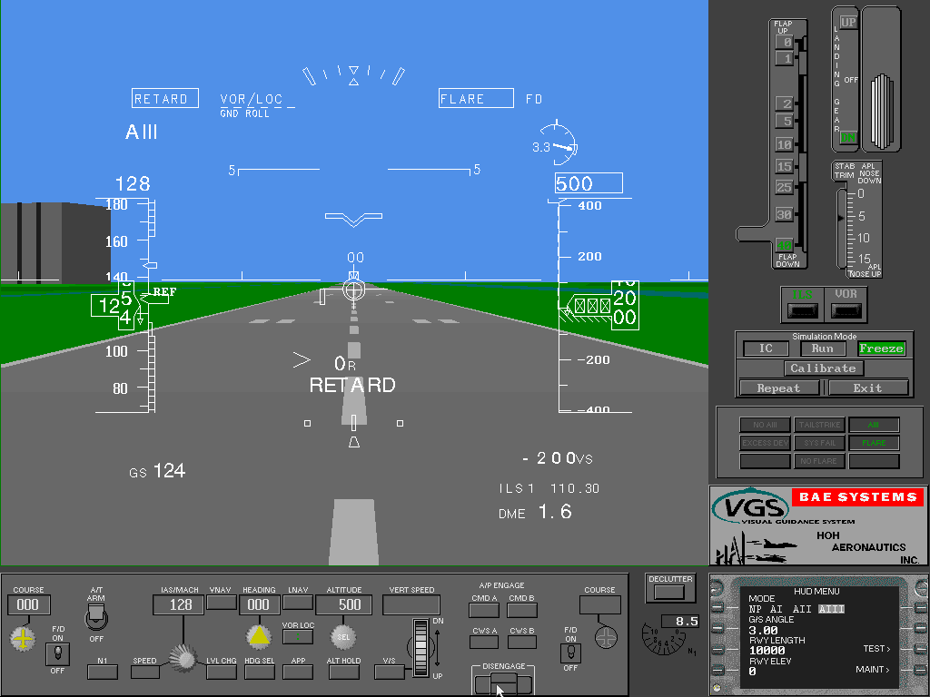

**SUMMARY OF VISUAL GUIDANCE SYSTEM FEATURES**

* A full time flare cue is available for all landings. This ensures a repeatable flare regardless of weather conditions, runway slope, etc.
* Runway Remaining is displayed during the takeoff and landing ground-roll
* Advisory ground-roll guidance is available for the landing rollout
* The ground-roll symbology is highly intuitive in that the flight director and raw data are combined into a single set of symbols (i.e., pursuit guidance). The takeoff guidance allows a reduction in takeoff visibility to 300 RVR.
* The HUD control laws provide tailstrike protection for landing through integration of an alert annunciation, TAILSTRIKE, and the full time flare cue
* The HUD control laws provide tailstrike protection on takeoff through advisory pitch guidance.
* The VGS is the firstHUD to be certified under the stringent requirements of FAA Advisory Circular AC 120-28D. Among other things, this required the demonstration of Monte Carlo simulation results and flight test validation at high altitude airports.
* The VGS is certified for Cat IIIa landings with all approved landing-flap settings (including 15 deg flaps), with one engine out, and with autothrottles on or off.
* An unusual attitude mode automatically appears to provide instant attitude awareness in the event of an aircraft upset. (Figure 3)
* The acceleration caret symbol provides the correct thrust lever command guidance to hold airspeed in all types of wind and windshear.
* An ENGINE OUT annunciation is provided in the event of an engine failure
* Mach compensated angle-of-attack is displayed along with the approach band and stick-shaker limit.

HAI also assisted Honeywell in the development of flare and low visibility takeoff guidance for a Fed Ex HUD that is FAA certified for use on the Boeing MD-11.

HAI is currently working on the guidance laws and symbology for a Cat IIIa HUD for a manufacturer of business jet in Europe.